**Data preprocessing is an important issue for data mining. What are the tasks in data preprocessing?**

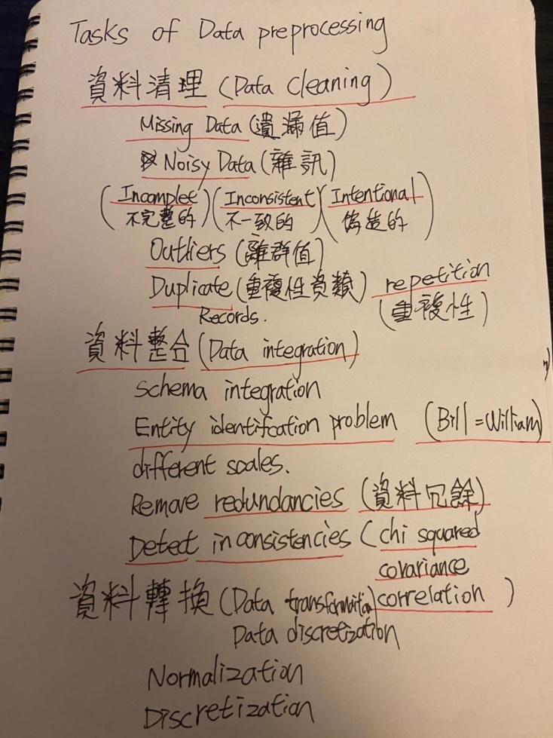

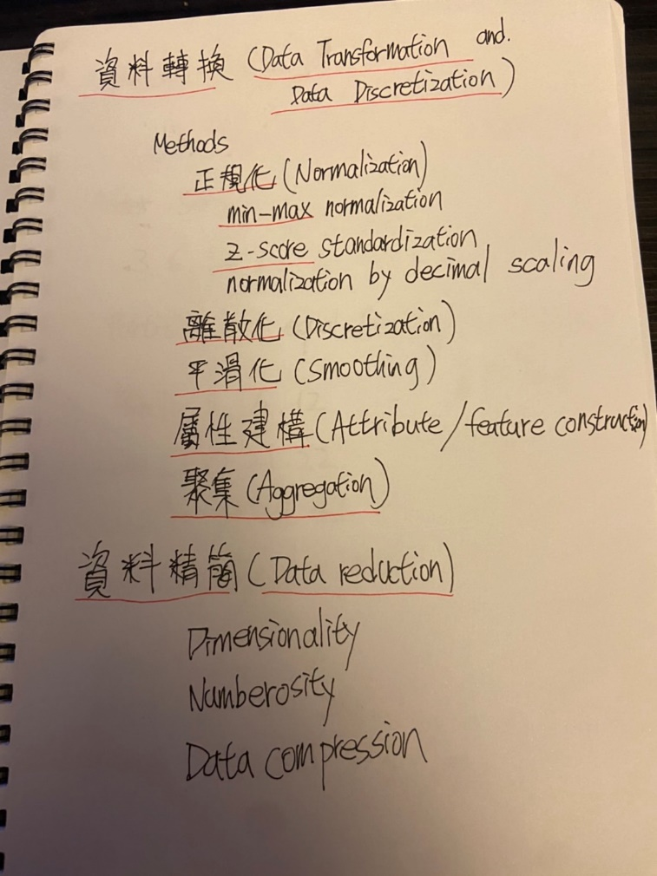

**Please use “Equal Width” and “Equal Depth” Binning Method to smooth the Dataset {17,42,3,29,12,21,6,29,22} into 3 boxes. Then, please use “Means”,” Median”, and “Boundaries” methods to eliminate the noisy data in final results, respectively.**

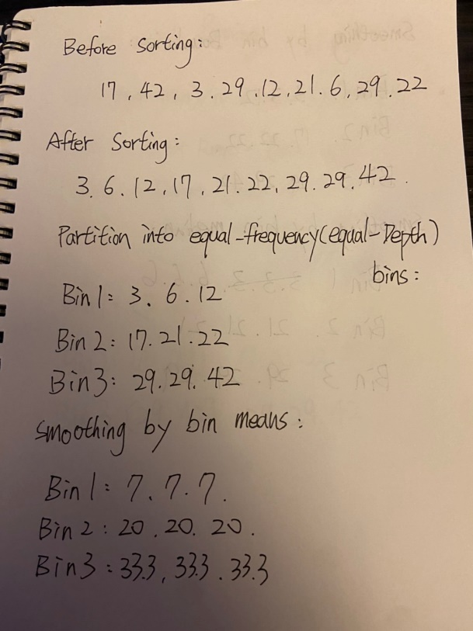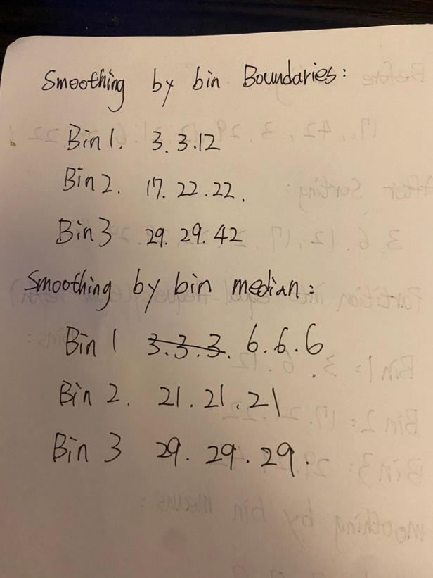

**median**

**means**

**Boundaries“Boundaries”**

**Equal-depth**

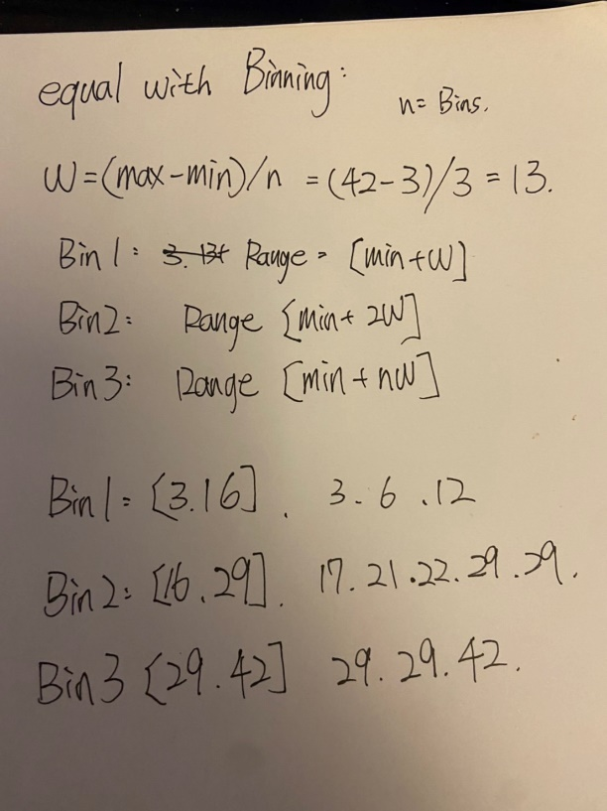

**Equal-width**

